**Introduction Of Hacking**

Hacking

Hacking refers to the practice of exploiting vulnerabilities in computer system, networks, or software’s to gain unauthorized access, disrupt services or steal dat. It can be performed by individuals or groups with malicious intent, skills to identify and fix vulnerabilities in a controlled and ethical manner.

OR

Hacking ek process hai jisme attacker victim ke system par exist kisi vulnerability ko exploit karke victim ke system ko compromise karta hai uss system ki unauthorized access lene ke liye.

OR

Hacking ka commonly used definition ki bat kare to hacking ek process hota hai jisme digital devices ko unme exist vulnerabilities ke through compromise karke uske resources ka unauthorized access lena.

OR

Hacking ek aisa process hai jisme digital devices and networks ki vulnerabilities, unke weaknesses ko exploit kiya jata hai jisse un digital devices ka unauthorized access leke unke resources ko apne according use kiya ja sake.

Ethical Hacking

In ethical hacking, a hacker uses their skills for good purposes. They utilize their skills, tools, and techniques to protect government and organizational digital devices, networks, and data from unauthorized access (bad hackers). The primary purpose of ethical hackers is to identify and fix vulnerabilities in government systems and networks to enhance their security.

Element of Information Security

information security is a state where data and system infrastructure remain protected, minimizing the risks of theft, tempering and disrupting to an acceptable or negligible level. Its primary goal is to safeguard sensitive information and digital resources from unauthorized access, modification and damage.

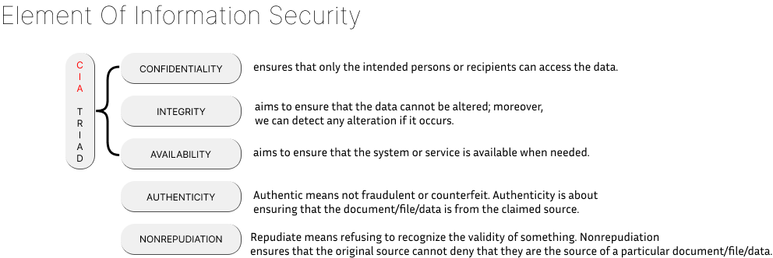

Phases Of Hacking(methodology)

* 5 Phase of hacking :
* **Information Gathering –** information gathering ke phase ko reconnaissance bhi kahte hai. Is phase target ke bare me information gather kiya jata hai chahe wo publicly available source se ho ya target se direct interact karke.

Reconnaissance ke bhi 2 types hote hai –

* Passive Reconnaissance : isme target ke sath bina direct interaction ke publicly available sources se information gather kiya jata hai.
* Active Reconnaissance :